**Edinburgh Airport Hotel**

**DoubleTree by Hilton Edinburgh Airport**

**Saturday May 30 – Sunday May 31 – 1 night.**

[Edinburgh International Airport, Edinburgh EH28 8LL, United Kingdom](https://www.google.com/maps/search/?api=1&query=DoubleTree+by+Hilton+Edinburgh+Airport%2C+Edinburgh+International+Airport+Edinburgh+GB)

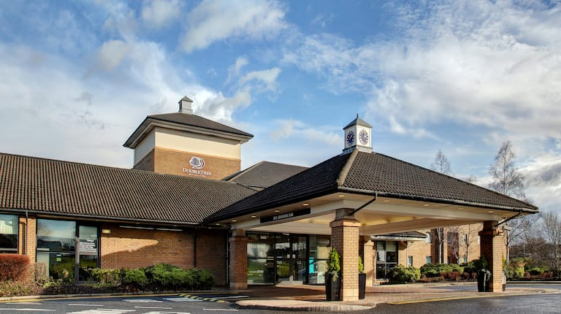

**Enjoy a restful night right by the airport**

We’re a half-mile from Edinburgh Airport via free airport shuttle. Six miles away are the Murrayfield Stadium and the zoo. Edinburgh City Centre sights like Princes Street, Royal Mile, and Edinburgh Castle are a thirty-minute drive. Enjoy our indoor pool, spa, fitness center, and all-day dining at The Space. Have a DoubleTree cookie on arrival.

3 rooms booked – 2 king bed and one 2 double beds.